Practical - 4
Practical Title: JavaScript DOM Manipulation, Event Handling, and UI Interactivity
Problem Definition: Add dynamic UI components such as collapsible FAQ, modal popup, image/content slider, notification banner, hamburger menu, and light/dark theme switcher using JavaScript.

Theory :
1. How are DOM elements selected and modified?

DOM manipulation means selecting an HTML element using JavaScript and then changing its text, HTML, style, attributes, classes, or values.

2. Are event listeners attached correctly?

Yes, event listeners are correctly attached using addEventListener(). It connects an HTML element with an event such as click or submit and executes a function when that event occurs.
3. Is localStorage used for remembering theme choice?

Yes. localStorage can be used to remember the user's theme choice. setItem() stores the selected theme, and getItem() retrieves it when the page is reopened, allowing the website to maintain the Dark/Light mode preference.
4. Does interactivity improve usability without breaking accessibility?

Yes. Interactivity improves usability when features such as buttons, notifications, menus, and forms make the website easier to use. Accessibility should be maintained by using proper HTML elements, keyboard support, readable text, clear messages, and sufficient contrast so all users can interact with the website.

Implementation/ Output/Result

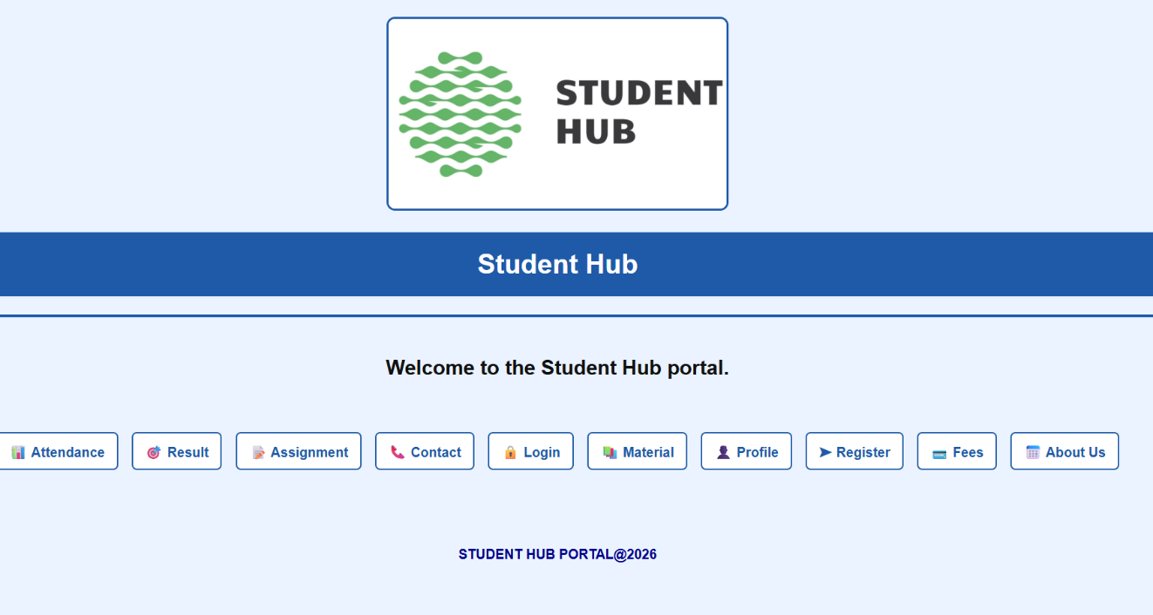

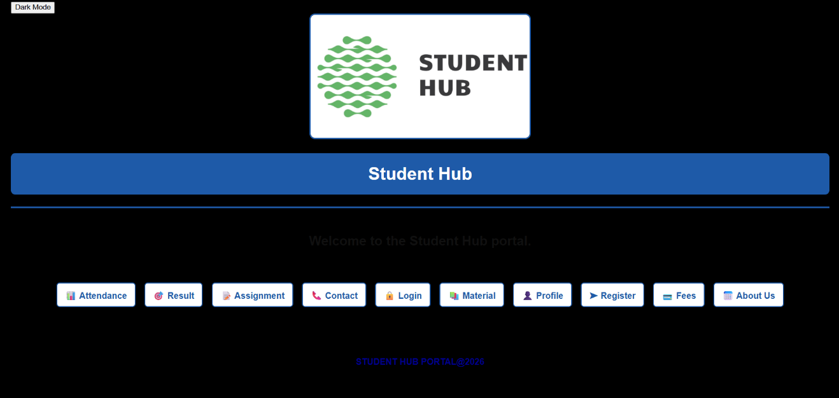

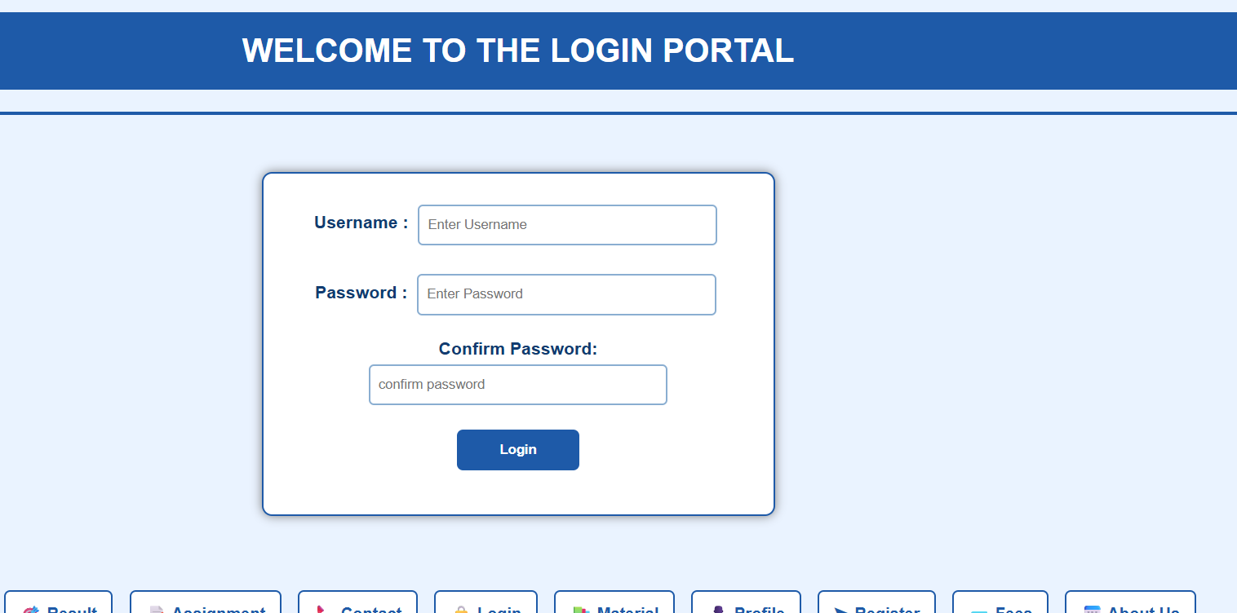

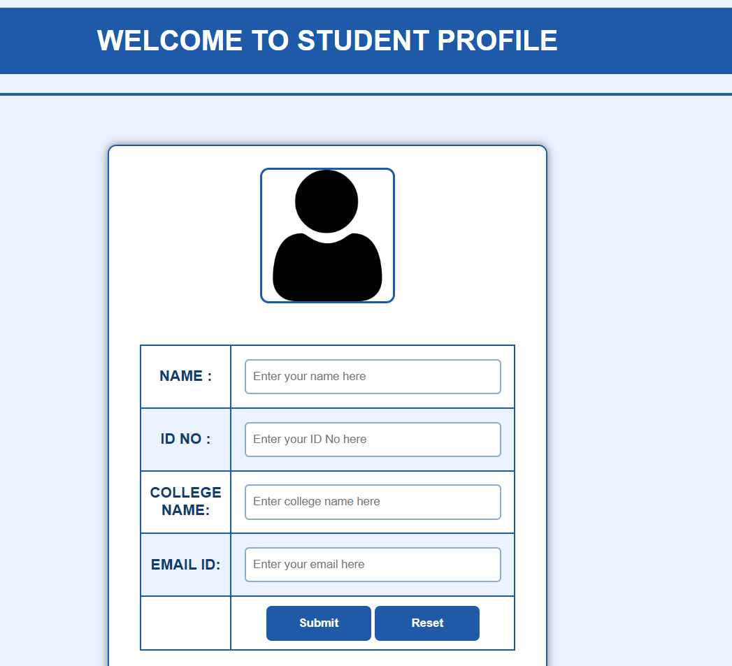
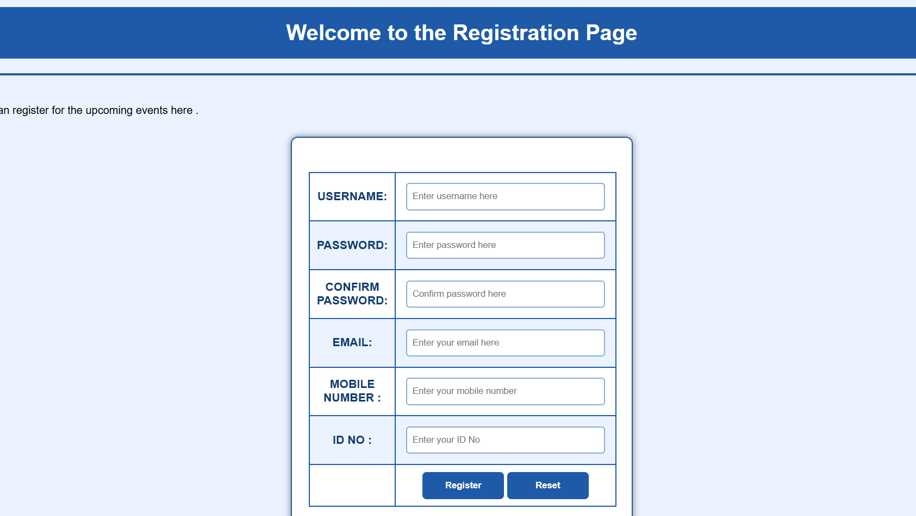

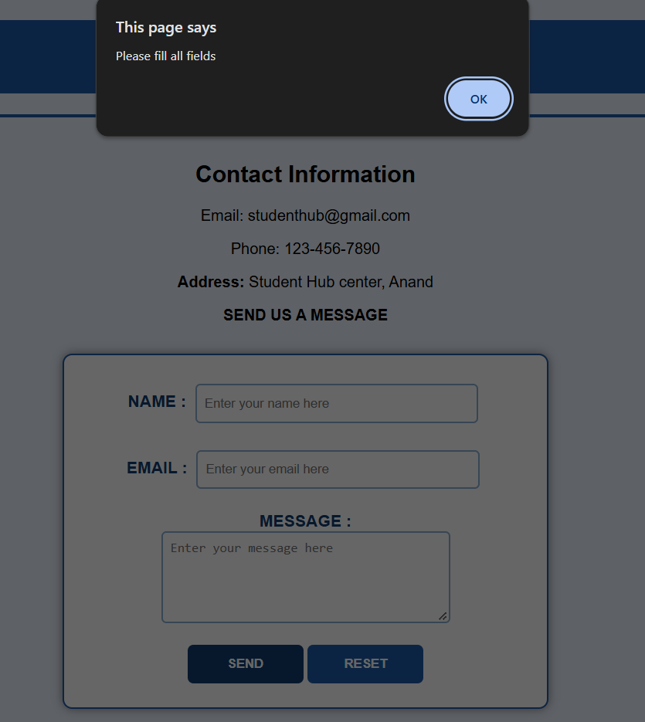

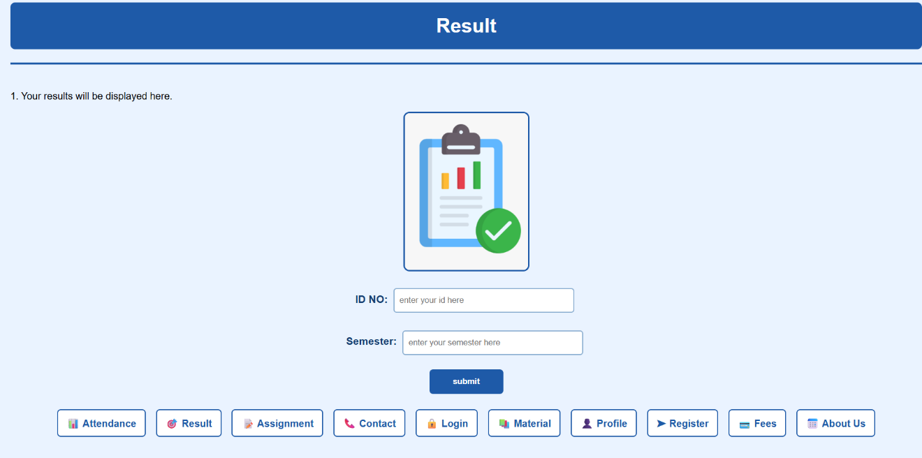

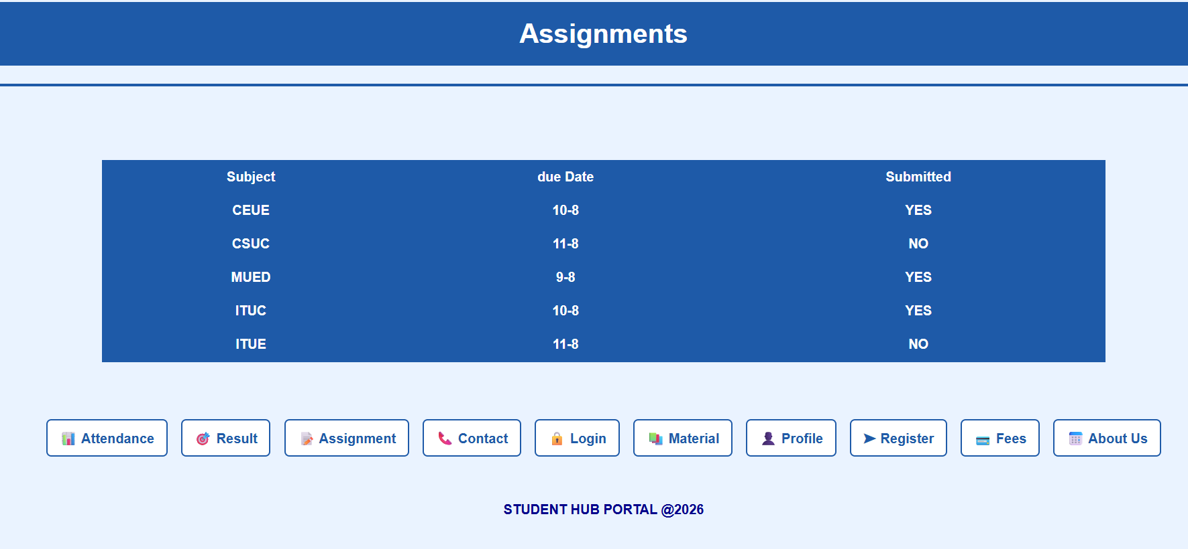

GitHub Repository Link:
https://github.com/25dce046/STUDENT-HUB-PORTAL/tree/main/PRACTICAL%204

Learning Outcomes:
- Use JavaScript DOM manipulation
- Handle user events like clicks and form submissions
- Create interactive UI components
- Implement dark/light theme switching
- Use localStorage to remember user preferences
- Improve the website's usability and interactivity.

